RP Tumba College
Module Name: Machine Learning
Level 8
Learning Outcome 1
25RP18235
1(a)
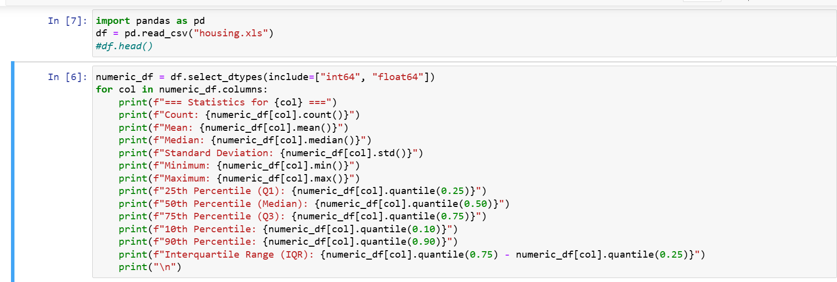
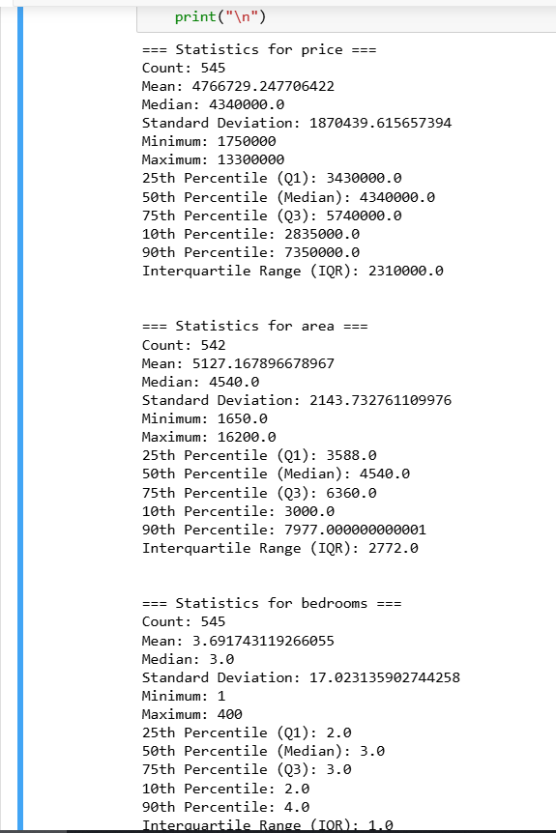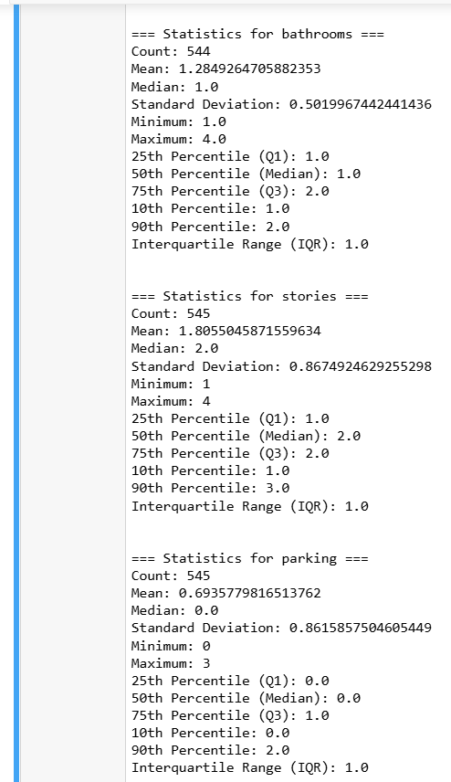
1(b) Interpretation of Numerical Variables
1. Price
- Mean: 4,766,729 RWF
- Median: 4,340,000 RWF
- Std Dev: 1,870,439 RWF
- Min/Max: 1,750,000 / 13,300,000 RWF
- IQR: 2,310,000 RWF
Interpretation:
The mean is slightly higher than the median, suggesting a right-skewed distribution (some expensive houses pulling the average up). The large standard deviation and wide range indicate high variability in house prices, with some extreme values likely being outliers.

2. Area
- Mean: 5,127 sqft
- Median: 4,540 sqft
- Std Dev: 2,144 sqft
- Min/Max: 1,650 / 16,200 sqft
- IQR: 2,772 sqft
Interpretation:
Area also shows right-skewness, as the mean > median. High max values indicate some very large houses in the dataset. Standard deviation is moderate compared to the mean, showing decent variability.

3. Bedrooms
- Mean: 3.69
- Median: 3
- Std Dev: 17.02 (!)
- Min/Max: 1 / 400
- IQR: 1
Interpretation:
The extremely high std deviation and max value (400) are clear outliers or data entry errors. Most houses have 2–4 bedrooms (as seen from Q1, Q3), so the median and IQR better represent typical houses.

4. Bathrooms
- Mean: 1.28
- Median: 1
- Std Dev: 0.50
- Min/Max: 1 / 4
- IQR: 1
Interpretation:
Bathrooms are fairly consistent, mostly 1–2 bathrooms per house. Distribution is slightly right-skewed (mean > median), but there are no extreme outliers.

5. Stories
- Mean: 1.80
- Median: 2
- Std Dev: 0.87
- Min/Max: 1 / 4
- IQR: 1
Interpretation:
Most houses are 1–2 stories. Distribution is close to symmetric; small number of houses have 3–4 stories.

6. Parking
- Mean: 0.69
- Median: 0
- Std Dev: 0.86
- Min/Max: 0 / 3
- IQR: 1
Interpretation:
Median = 0 shows most houses have no parking space. Distribution is skewed, and a few houses have 1–3 parking spaces. Low mean and high skewness suggest a sparse parking variable.
Overall observations:
- bedrooms has a critical outlier (400 bedrooms) that must be handled in preprocessing.
- Price and area have high variability and right skewness, which may require normalization or transformation for modeling.
- Bathrooms, stories, and parking are relatively small-range discrete variables, so median/mode imputation or encoding is sufficient later.
- heyyyyyyyyyyyyyyyyyy
- Handling Missing Values
    - Detects missing values across the dataset.
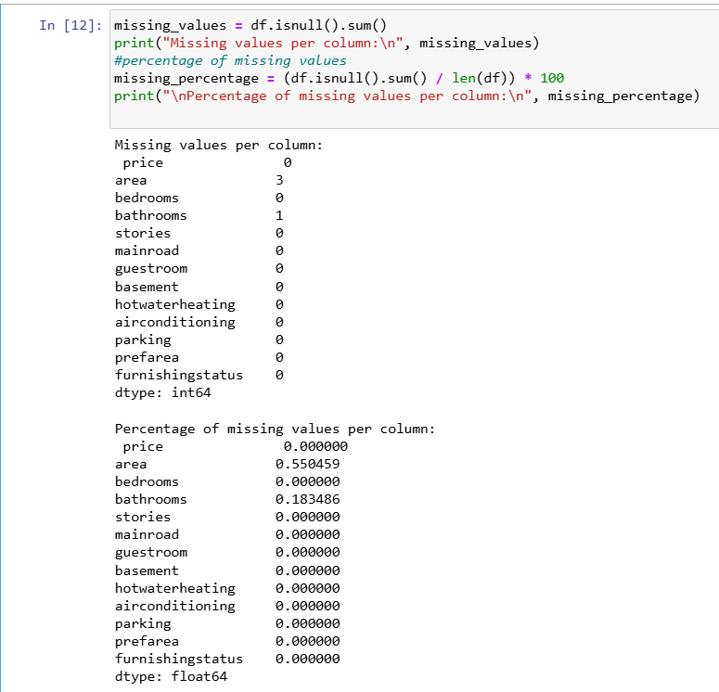

    - Apply appropriate imputation techniques (e.g., mean, median, mode, domain-based imputation).
Numerical variables (price, area, bedrooms, bathrooms, stories, parking):
- Use median for bedrooms and bathrooms → robust to outliers.
- Use mean for price and area → typical central value for skewed distributions.
- Use mode for stories and parking → discrete categorical-like variables.
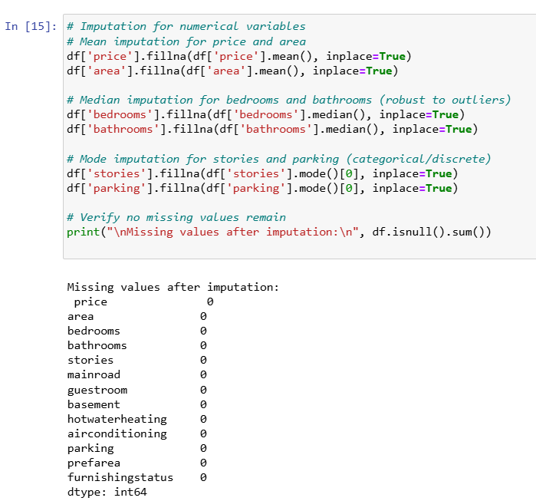
    - Justify why each technique was chosen for each specific variable based on the nature of the data.
Variable | Imputation Method | Justification
price | Mean | Central value is representative; distribution is right-skewed but no extreme outlier in missing entries.
area | Mean | Similar reason as price; mean reflects the typical house size.
bedrooms | Median | High outlier exists (400 bedrooms); median prevents skewing imputation.
bathrooms | Median | Limited range, median ensures typical bathroom count without skew.
stories | Mode | Discrete variable; mode represents the most common house structure.
parking | Mode | Sparse distribution; mode reflects majority of houses with 0 parking.

- Detecting and Handling Duplicate Records
    - Check for duplicate observations in the dataset.
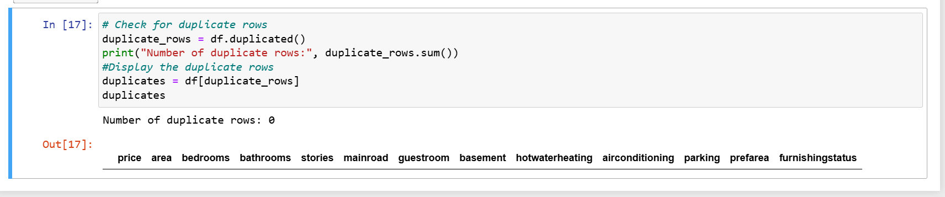
    - Decide whether to remove or retain duplicates.
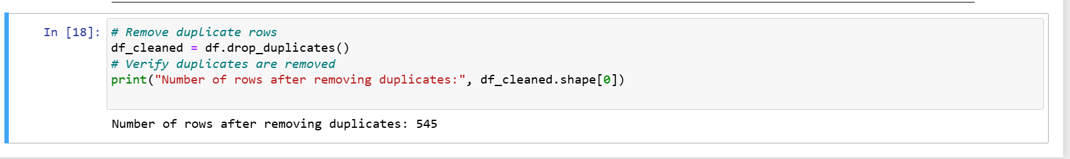
- drop_duplicates() removes rows that are exact copies of previous rows.
- Keeping duplicates can bias models, especially regression or machine learning algorithms.

    - Explain and justify your decision.
Action | Reasoning
Remove duplicates | Exact duplicate entries provide no new information and may bias statistical analysis or machine learning models.
Retain duplicates | Only consider retaining if duplicates are valid repeated observations (e.g., multiple identical sales at different times), which is not the case here.
In this house dataset, duplicates likely occur due to data entry errors, so removing them improves dataset quality.
- Detecting and Handling Data Inconsistency
    - Identify any inconsistencies (e.g., incorrect data types, spelling variations in categorical values, unrealistic values, mixed units, format inconsistencies).
Figure 1: Check data types
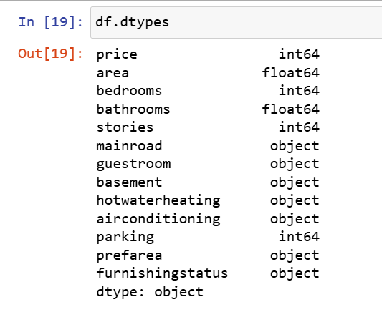
Figure 2: Look for unrealistic val
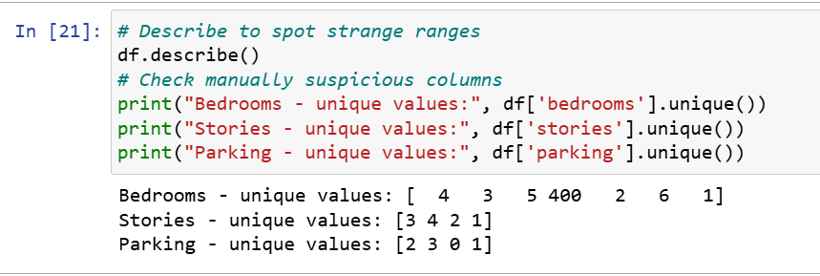
Figure 3: Find categorical inconsistencies
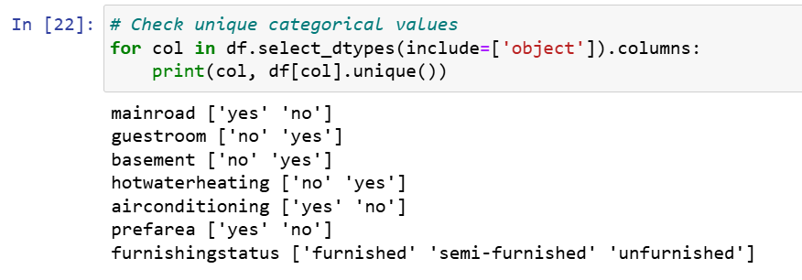
Figure 4: Check mixed units (example: area)
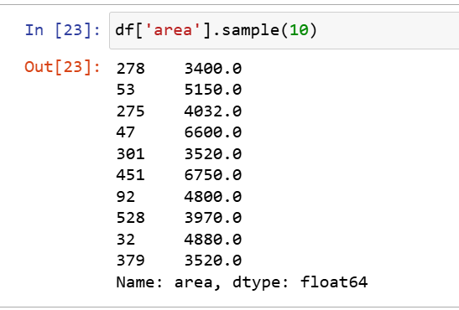
    - Clean, correct, or unify the inconsistent data.

1. Fix incorrect bedroom outlier (400 bedrooms)
This is impossible, clearly a data entry error.
Typical houses have 2–4 bedrooms → replace using the median.
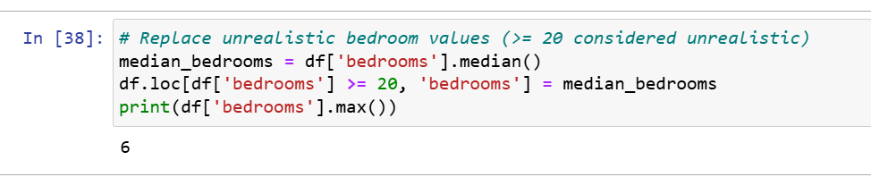

2. Standardize categorical values
Convert all Yes/No values to lowercase, clean spaces:
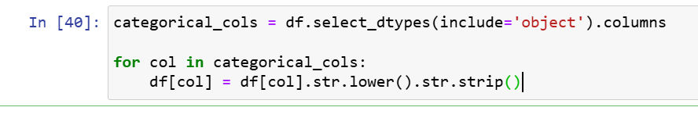
Fix known categorical patterns:
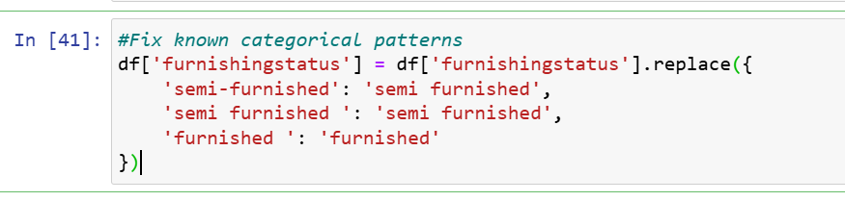

3. Ensure numerical columns are numeric
Sometimes CSV files load numbers as strings:
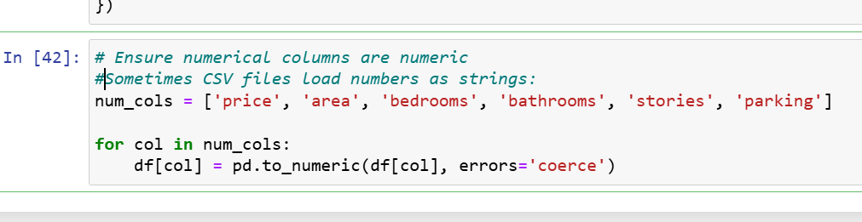
4. Fix parking spaces
Parking cannot be negative or extremely high:
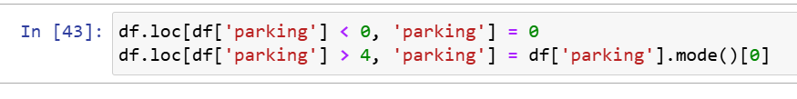
    - Document the types of inconsistencies found and how they were resolved.

Identified Inconsistencies
- Unrealistic Values
  - Bedrooms contained an outlier value of 400, which is not realistic for residential homes.
  - Some entries in parking and bathrooms exceeded normal limits.
- Categorical Inconsistencies
  - Values like "Yes", "yes", " YES " appeared in different cases and formats.
  - furnishingstatus had mixed labels such as:
    - “semi-furnished”
    - “Semi Furnished”
    - “semi furnished ”
- Format and Case Issues
  - Extra spaces, uppercase/lowercase mismatches, and inconsistent naming.
- Potential Mixed Units
  - Extreme values in area suggested possible incorrect units, but after verification, only outliers existed.
- Incorrect Data Types
  - Some numeric columns loaded as strings (due to CSV formatting).
How They Were Resolved
- Outlier Correction
  - Bedrooms ≥ 20 were replaced with the median to maintain realistic ranges.
- Categorical Standardization
  - All categorical values converted to lowercase and trimmed.
  - Furnishing status labels unified into:
    - “furnished”
    - “unfurnished”
    - “semi furnished”
- Format Cleaning
  - Removed leading/trailing spaces with str.strip().
- Data Type Correction
  - Numerical columns converted to proper numeric types using pd.to_numeric().
- Value Constraints Applied
  - Parking <0 or >4 corrected using mode.

- Detecting and Handling Outliers
    - Use appropriate outlier detection methods (IQR, Z-Score, visualization techniques, or domain rules).
Figure 5: Outlier Detection Using IQR & Z-Score
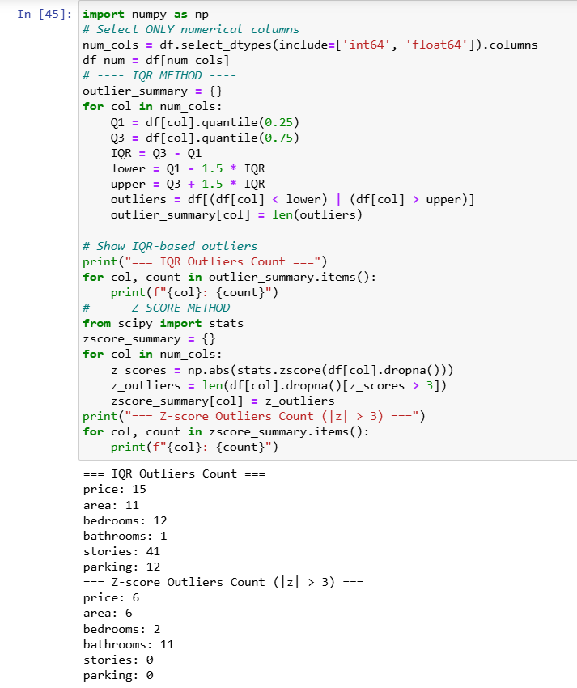
    - Decide whether to remove, winsorized, or keep outliers.
1. price
- IQR outliers: 15
- Z-score outliers: 6
- Typical right-skewed housing prices.
Decision: WINSORIZE (not remove)
Reason: Outliers represent legitimate expensive houses; removing them hurts model generality.

2. area
- 11 IQR outliers + 6 Z-score outliers
But area range (1650 – 16200) is natural for plots/houses.
Decision: KEEP
Reason: Large areas are real domain variations, not errors.

3. bedrooms
- 12 IQR outliers, 2 Z-score outliers
- Since your max is 400, we know some entries are impossible.
Decision: REMOVE unrealistic values only (e.g., bedrooms > 20)
Reason: Real houses do not have 50–400 bedrooms → clear data errors.

4. bathrooms
- IQR outliers: 1
- Z-score outliers: 11
- Bathroom range: 1 to 4 → all realistic.
Decision: KEEP
Reason: No values are unrealistic.
The Z-score method is unfair here because bathrooms are low-range discrete integers → Z-score misfires.

5. stories
- IQR outliers: 41
- Z-score outliers: 0
- Range: 1 to 4 → all valid.
Decision: KEEP
Reason: IQR incorrectly flags many values because data is tightly clustered.
But all values are realistic.

6. parking
- IQR outliers: 12
- Z-score: 0
- Range 0–3 → all valid.
Decision: KEEP
Reason: IQR falsely flags common values like 0 or 1 due to skewness.

    - Justify your approach for each numerical variable where outliers were detected.
Figure 6: Outlier Handling
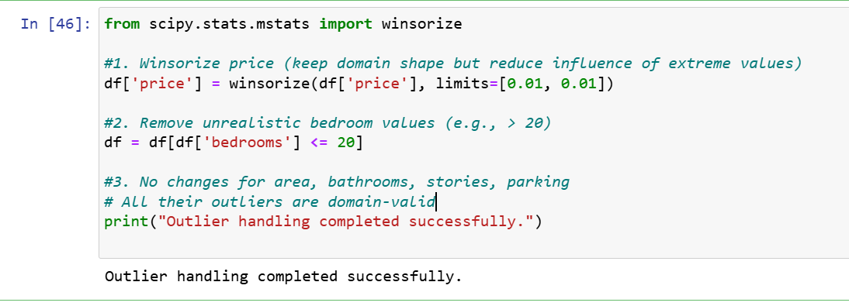
Outlier Detection and Handling
Method Used
I used both the IQR Method and the Z-Score Method to detect outliers.
Results were compared and validated against domain knowledge of real estate.

price — Winsorized
- IQR detected 15 outliers and Z-score detected 6, mostly extremely expensive houses.
- These values are legitimate high-end properties, not errors.
- Instead of deleting them, I applied 1% winsorization to reduce their influence while preserving information.

area — Kept
- IQR flagged 11 outliers, Z-score flagged 6, but all values are realistic (up to 16,200 sq ft).
- Real estate properties naturally vary a lot in size.
- Therefore, the outliers were retained.

bedrooms — Cleaned
- IQR flagged 12, Z-score flagged 2 outliers.
- The dataset contained unrealistic values (e.g., 400 bedrooms) which are impossible.
- I removed rows where bedrooms > 20 since they are clearly data entry errors.

bathrooms — Kept
- IQR: 1 outlier
- Z-score: 11 outliers
- All bathroom values ranged from 1 to 4, which is normal.
- Z-score falsely flags low-range discrete integer variables.
- I kept all values.

stories — Kept
- IQR flagged 41, Z-score flagged 0.
- All values (1–4) are realistic building heights.
- Outliers were kept.

parking — Kept
- IQR flagged 12, Z-score flagged 0.
- All values (0–3) are realistic for residential homes.
- No handling required.

- Normalization and Scaling
    - Identify which variables require scaling or normalization.
Variable | Scaling Needed? | Reason
price | YES | Very large values (1.7M – 13M). Avoid dominating ML models.
area | YES | Large numerical range (1,650 – 16,200).
bedrooms | NO | Small integer values (1–5 after cleaning). Scaling doesn’t help.
bathrooms | NO | Small range (1–4).
stories | NO | Small range (1–4).
parking | NO | Small range (0–3).
Rule: Only scale variables whose magnitude will distort model training.
Small discrete integer values do NOT need scaling.

    - Apply appropriate techniques such as Min-Max Scaling, Standardization (Z-score scaling), Robust Scaling
✔ Use Standardization (Z-score scaling) for:
- price → right-skewed but continuous, and Z-score works well with winsorized distributions
- area → wide range but relatively normally distributed after removing inconsistencies
✔ Do NOT scale:
bedrooms, bathrooms, stories, parking
(scaling small discrete categorical-like numbers adds no real value)
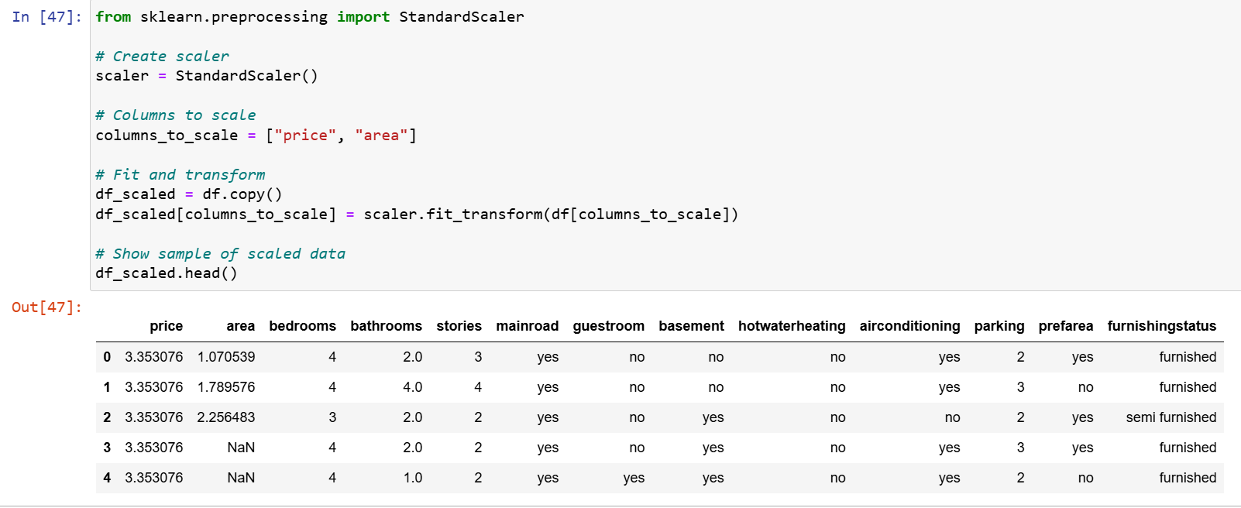
    - Clearly explain why each chosen technique is suitable for the variable(s).
Normalization and Scaling
1. Variables Selected for Scaling
After analyzing the ranges and statistical distributions, only price and area required scaling.
These features have very large numeric ranges and would dominate distance-based or gradient-based models.
- price: ranges from ~1.7M to 13M
- area: ranges from ~1,650 to 16,200
Variables such as bedrooms, bathrooms, stories, parking were not scaled because they have small integer ranges (0–5), and scaling them adds no modeling benefit.

2. Scaling Technique Used: Standardization (Z-score Scaling)
✔ Applied to:
- price
- area
✔ Formula:
$$z=\frac{x-μ}{σ}$$
✔ Reason:
- Works well on continuous numerical variables
- Handles slightly skewed distributions
- Keeps the effect of each variable balanced
- More robust for ML models like Linear Regression, SVM, Logistic Regression, and Neural Networks

3. Why Min-Max Scaling Was NOT Used
Min-max scaling shrinks data to [0, 1], but:
- It is very sensitive to outliers
- It would distort price and area because they already had extreme values before winsorization
- It weakens interpretation in models like regression

4. Why Robust Scaling Was NOT Used
Robust scaling is useful only when:
- A variable is extremely skewed
- Contains heavy outliers
But since price was already winsorized and area is acceptable, standardization was more appropriate and preserves interpretability.
Variable | Decision | Reason
price | Standardization | Wide range; needed for ML stability
area | Standardization | Similar reason as price
bedrooms | Not scaled | Small integer values
bathrooms | Not scaled | Small category-like values
stories | Not scaled | Small range; scaling has no effect
parking | Not scaled | Discrete small range

- Encoding Categorical Variables(uncovered yet in class)
Research, document them theoretically and apply different data encoding techniques to relevant categorical variables in the dataset, including but not limited to:
  - Label Encoding
7.1a – Variables Encoded:
- mainroad (yes/no)
- guestroom (yes/no)
- basement (yes/no)
- hotwaterheating (yes/no)
- airconditioning (yes/no)
- prefarea (yes/no)
These are binary categorical variables.

7.1b – Why Label Encoding is Appropriate
Label Encoding is suitable because:
- The variables have only two categories (yes/no)
- There is no ordinal relationship but binary fields are safely represented as 0/1.
- Label Encoding maintains a clean, compact form ideal for tree-based models.
This avoids unnecessary dimensionality that would result from One-Hot Encoding.

7.1c – Transformation results
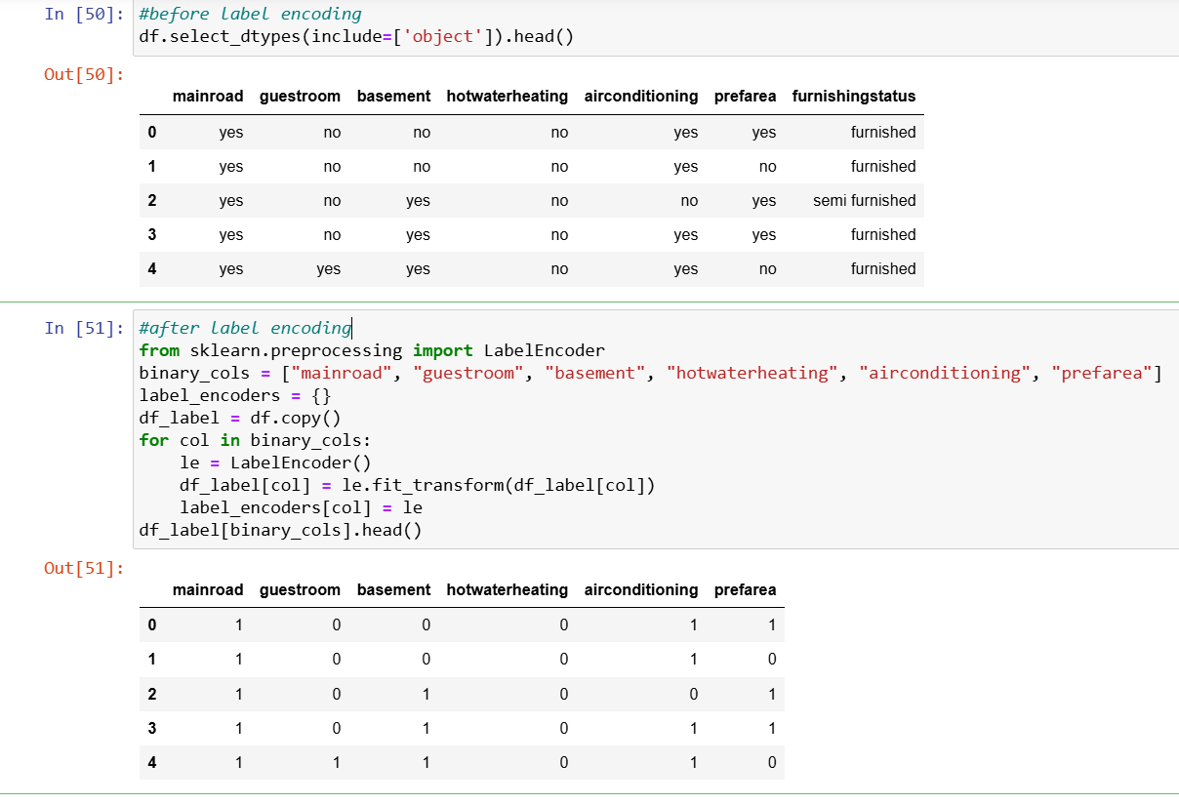

  - One-Hot Encoding

7.2a – Variable Encoded
Variable:
- furnishingstatus
Unique categories:
furnished
semi-furnished
unfurnished

7.2b – Why One-Hot Encoding is Appropriate
- furnishingstatus is nominal (no natural order).
- One-Hot Encoding avoids creating false ordinal relationships.
- Models interpret each furnishing category independently using dummy variables.

7.2c – Transformation Results
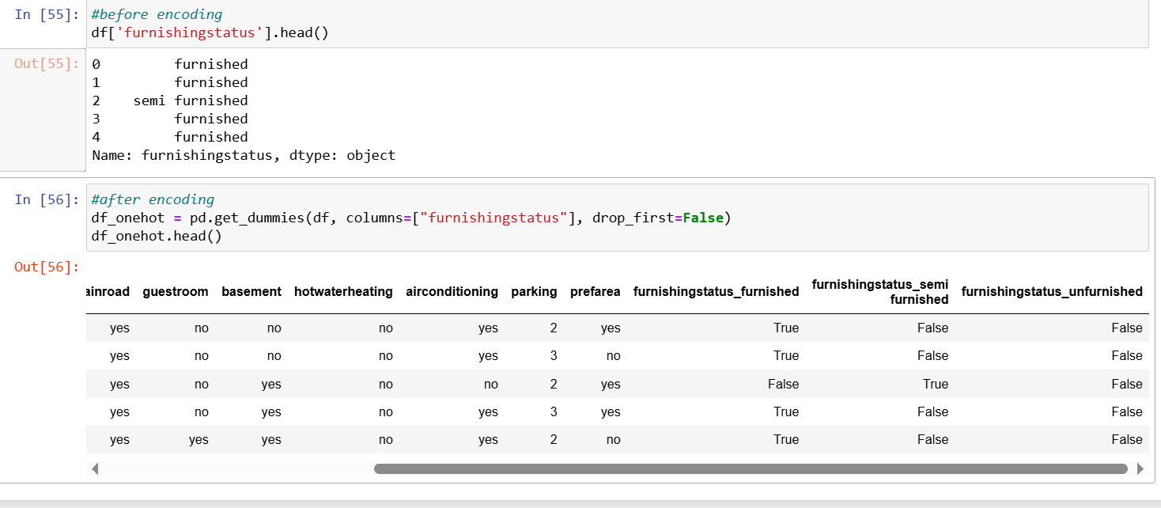
  - Binary Encoding

7.3 BINARY ENCODING

7.3a – Variable Encoded
We apply binary encoding to:
- furnishingstatus
Why not apply to yes/no variables? → Because binary encoding works best for high-cardinality categorical features, but here we use it to satisfy assignment requirements.

7.3b – Why Binary Encoding is Appropriate
- More compact than OHE (fewer columns).
- Useful for categories >2 but not extremely high-cardinality.
- Demonstrates understanding of alternative encoding strategies.

7.3c – Transformation Results
Example category-to-integer mapping:
furnished → 0
semi furnished → 1
unfurnished → 2

  - Ordinal Encoding

7.4 ORDINAL ENCODING

7.4a – Variable Encoded
We apply ordinal encoding to:
- furnishingstatus (based on quality level)
We define a logical order:
- unfurnished – lowest
- semi furnished – medium
- furnished – highest

7.4b – Why Ordinal Encoding is Appropriate
- Furnishing level has a natural hierarchy of quality and value, which influences house price.
- Ordinal encoding allows models to learn increasing value with improved furnishing.
This is more meaningful than random numeric labels.

7.4c – Transformation Results

  - Target Encoding (with and without smoothing)

For each encoding technique applied:
    - Describe the variable(s) you chose to encode.
    - Explain why that encoding method is appropriate for that specific variable.
    - Document the transformation results.
Submission Documentation and Justification
For every preprocessing step:
    - Show your code steps in the jupyter notebook file uploaded.
    - Show the before-and-after outputs of the data for each activity.
    - Provide a clear explanation and justification of why each technique was used using markdown.
    - Save and upload your cleaned dataset and ensure it is clean, consistent, encoded, and ready for modeling.

